UDC 316.74:801
INTERCULTURAL COMMUNICATION
Alieva.M.B. associate professor, Jumabekova G. Sh.,
Almaty Technological University, Almaty, Republic of Kazakhstan,
marta.ali777@mail.ru guzika_j@mail.ru

Intercultural communication is a form of communication that aims to share information across different cultures and social groups. It is used to describe the wide range of communication processes and problems that naturally appear within an organization or social context made up of individuals from different religious, social, ethnic, and educational backgrounds.
Intercultural communication is defined as situated communication between individuals or groups of different linguistic and cultural origins. This is derived from the following fundamental definitions: communication is the active relationship established between people through language, and intercultural means that this communicative relationship is between people of different cultures, where culture is the structured manifestation of human behavior in social life within specific national and local contexts, e.g. political, linguistic, economic, institutional, and professional. Intercultural communication is identified as both a concept and a competence. Intercultural competence is the active possession by individuals of qualities which contribute to effective intercultural communication and can be defined in terms of three primary attributes: knowledge, skills and attitudes. In the context of this document, the acquisition of skills and human attributes likely to enhance intercultural communication is viewed exclusively as a component of language programmes, i.e. as an accompaniment to the practical acquisition of language itself.
Intercultural communication is of importance to international businesses as it examines how people from different cultures, beliefs and religions come together to work and communicate with each other [1].
Demands for intercultural communication skills are increasing as more and more businesses go global or international. They realize that there are barriers and limitations when entering a foreign territory. Without the help of intercultural communication they can unknowingly cause confusion and misunderstandings. For these intercultural businesses to breach the cultural barriers encountered when stepping into foreign grounds it is vital for them to fully understand the cultural differences that exist so as to prevent damaging business relations due to intercultural communication gaps.
There are many theories that set principles to help interpret the basis of intercultural communication. These theories help to iron out possible ripples of misunderstanding by giving a basic guideline on how to address situations. These guidelines help prevent clashes between different cultures groups caused by misperceptions.
The basic skills of intercultural communication are fundamentally general communication skills that can be used universally by all cultures and races. These skills are simply tweaked in a direction that takes the cultural limitation into consideration. An example of such communication skills in the intercultural environment is to listen without judging, repeat what you understand, confirm meanings, give suggestions and acknowledge a mutual understanding [2].
In a nutshell the main purpose of following such theories is to earn respect from others. Respect in all cultures in the world is a common language and by earning it through respecting other peoples culture and religion; the favor is returned.
It is important to increase our awareness of and sensitivity to culturally different modes of behavior. We need to recognize different cultural patterns at work in the behavior of people from other countries and cultures.
As it was shown above that intercultural communication is essential there plenty of scientists and linguists who study this notion and try to give us right directions, competences and skills to communicate and understand people from different cultures and backgrounds. For example our scientists, linguist S.S.Kunanbaeva points out that nowadays without having intercultural communicative competence it is difficult to develop and share information in correct order. She distinguishes different types of intercultural communicative competences. They are: communicative competence, cognitive competence, informative, cultural and emotive competencies. If person possesses all these competences as a result we could get a subject of intercultural communicative competence [3].

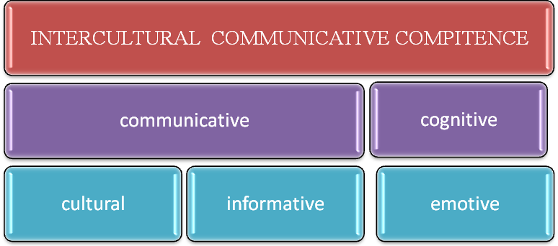

It is also useful to be aware of how our own cultural background influences our behavior. And we need to develop tolerance for behavior patterns that are different from our own.
Some useful areas to look at are:
- Silence
- Time
- Distance and personal space
- Touching
- Body language
- Posture & movement
- Eyecontact

Why is it important to improve intercultural communication?
Lack of knowledge of another culture can lead, at the best, to embarrassing or amusing mistakes in communication. At the worst, such mistakes may confuse or even offend the people we wish to communicate with, making the conclusion of business deals or international agreements difficult or impossible.
Mahatma Gandhi says , “I do not want my house to be walled in on all sides and my windows to be stuffed. I want the cultures of all the lands to be blown about my house as freely as possible. But I refuse to be blown off my feet by any.” From his words we can see that it is important to be tolerant to other cultures .
To conclude, we would like to mention that it is very important to speak foreign language, especially English language to understand the people of the world. As our president N.A.Nazarbaev integrates triangle of three languages: Kazakh, Russian and English, we can surely say that for bright future of tolerant and peaceful nation Intercultural communication should be under great consideration.

References
  - Samovar, Larry A., and Richard E. Porter. "Chapter 1." Intercultural Communication: A Reader. Belmont, CA: Wadsworth, 2011. 8. Print.
- Wiseman , Richard L. ( 2003), " intercultural communication competence" , in Gudykunst, William B ( Ed.) , Cross-cultural and intercultural communication , 191-208, Thousand Oaks: Sage.
- S.S.Kunanbaeva, Theory and practice of intercultural communicative competence. 2010.

