UDS 664.7/665.3

EFFECT OF MOISTURE AND THE HYDROTHERMAL TREATMENT ON THE MECHANICAL PROPERTIES OF SEEDS
Baibolov K., Baibolova L., Tutebaeva K.,
Kemerbekova A., Alybayeva M.

It is known that vegetable oils are the main sources of "useful" fat. They include unsaturated fatty acids, vitamins, minerals, easily assimilated by the body and do not give deposits on the walls of the intestine and vitamins help maintain the integrity of mucous membrane of the gastrointestinal tract, prevent the appearance of severe vascular diseases, increase body's resistance to the harmful effects of viruses, bacteria and the environment, i.e., as antioxidants [1,2,3].
Advantage of vegetable oils to animals is the use of animal oils increases the content of cholesterol in blood, weakens work of cardiovascular system, a liver, and kidneys and caused of fats deposition. At the moderate use of sesame and linseed oil, especially oil supplements, indicated disadvantages are not observed.
To produce high-quality oil with BAA is necessary to use effective methods of seed preparation. There are several processing methods that improve the quality of raw materials. One is a hydrothermal treatment, then the HTТ, which increases the yield of the finished product, improves the nutritional value, the product develops a pleasant taste.
Moisture, temperature and duration of thermal influence have significant effect on structural and mechanical properties of seeds. Seeds plasticity has risen by increasing of moisture content, as a result plastic and general deformation at compression increases, and elasticity decreases. Especially sharp changes come at humidity 15…16 %. Temperature has impact on structural and mechanical properties of grain too. At low temperatures (up 10 °C) elastic properties are more significant, than at raised (10-20 °C), at the further temperature increase value of relative deformation continues to grow according to the rectilinear law [4,5]. HTT has impacts on all properties of grain and, eventually, it effects on technological properties owing to their dependence on biochemical, structural and mechanical and other properties.
As a result of studying of influence of humidity of seeds and the modes of hydro heat treatment on technological and mechanical properties the optimum modes of hydro heat treatment have been defined.
The object of the study was the sesame seeds from South Kazakhstan and flax from Kostanay Region of Kazakhstan, 2015 harvest.
Moisture of initial sample was adjusted from 9.2 to 15.2 % in 2 %. Seeds with initial moisture 9, 2 % have been steamed at P=0, 1, 0, 2 and 0, 3 MPas within 3 min. (figure 1).
Steamed seeds dried (Figure 2) by laboratory fluidized bed method.

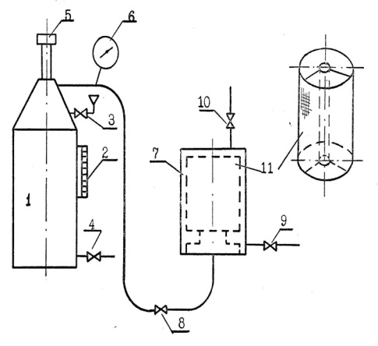 | 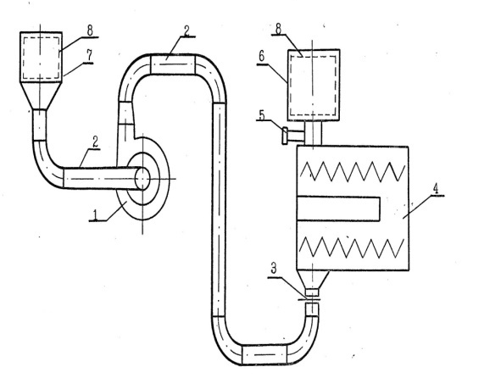
Figure 1. Scheme of the laboratory set for grain steaming:  1-steamer; 2-water meter tube; 3-tap for pouring water; 4-tap for water drainage;  5-safety valve; 6-manometer; 7-steamer; 8-steam supply valve; 9-tap for derivation of condensate; 10-tap for derivation of steam; 11-cassette for grain | Figure 2. Scheme of the laboratory  set for drying and cooling:  1-fun; 2-air duct; 3-valve (the latch); 4-electric heater; 5-thermometer;  6-drying chamber; 7-cooling chamber;  8-cassette with product

Firmness properties were determined by compression method. On HTT starch dissolves and fills all pores, the subsequent drying process harden them, the nucleus becomes hard, improved processing properties [4].
Further studied influence of moisture of seeds of sesame on the destroying efforts. The nature of the changes ongoing efforts remains the same. At humidity of seeds from 9, 2 to 18, 2 % insignificant decrease in the destroying efforts (from 20 N to 18,6 N) is observed whereas change of size of relative deformation is more noticeable (from 31 to 63 %). The seeds are more damp, the size of relative deformation ε is higher, the %, so for drier grain ε within 35 to 60 %, for damp ‒ 65-85 %, grain becomes more plastic. Therefore, than the grain is damper, the more efforts required for destruction.
Duration of steaming effects on grain strength significantly. For this purposes Seeds steamed at a pressure of P = 0, 10 MPa during 1, 3 and 5 minutes. After seeds dried up to moisture content of 9,2 %. In this case, the processing time significantly influences the technological properties of the seeds. In all cases, the best results are obtained when seeds steamed during 3 min. The rate of technological efficiency of the process at P = 0,1MPa during 3 minutes was 84,1 %, which is greater than the control at 10 for 1 to 2 min steaming and by 4 % during 5 min processing.
Thereby, steam treatment is the most effective during 3 min. It was found that sesame seed hydrothermal treatment causes a small increase of core strength increases its plasticity. Hard steaming modes cause a slight increase of the core strength, its fragility. The most effective modes of steaming: steam pressure of 0.1 MPa, the duration of steaming up to 3 minutes.

List of sources used

1 Baibolov K., Baibolova LK., Kusainov A.M. A comparative analysis of the technological process and the physicochemical properties of oils of black cumin and sesame like BAA // Vestnik SemNational University. ‒ Semey, 2011. ‒ №4 (56). ‒ Page.58-63.
2 Baibolov K., Kusainov A.M. Development of the technological process of the vegetable oil production of sesame seeds // Food technology and service. – 2010. ‒ №4. ‒ Page. 19.
3 Baibolova L.K., Baybolov K.B., Kemerbekova A.K., Tutebayeva K.E., On the possibility of the use of oilseeds in the manufacture of products directed action. Food innovation and biotechnology: Materials of International sciantific forum / edited by. А.Yu. Prosekova; Federal State Educational Institution of Higher Professional Education, Kemerov Technological Institute of Food Industry. – Kemerovo, 2013. – Page. 57-62.
4 Baibolova L., Kulazhanov T., Rskeldiev B., Tutebaeva K., Dzhinguilbayev S., Kemerbekova A. Development of foodstuff of the directed action on the basis of national cutting of mutton. Journal of Food and Packaging Science, Technique and Technologies // Proceeding of conference 40 years department Machine and apparatus of food industry of University of Food Technologies. – Bulgaria, 2013. – № 2. – Р. 260-264.
5. Technology of cereals and cereal concentrates. Textbook. /A. Iztaev, К.B.Baybolov, А.B. Mynbayevа/ ‒ Almaty. ‒ 2014. ‒ Page 408.

