УДК 687.123
DEVELOPMENT OF A DESIGN DRAWING FOR WOMEN'S TROUSERS FOR WOMEN WITH LIMITED ABILITIES, TAKING INTO ACCOUNT THE DYNAMIC POSTURE OF A PERSON
Arnauyt S.A., Zhilisbayeva R.O., Doctor of Technical Sciences, Professor., Almaty Technological University, Almaty., Republic of Kazakhstan, E-mail: sandu_94love@mail.ru, Rau_45@mail.ru

Analysis of the conditions of use of clothing for persons with disabilities
When designing clothes for people with disabilities, a number of important criteria must be taken into account. To ensure the functionality of clothing you need:
• Identify the conditions for the use of clothing (operating conditions determine the type of clothing, its basic parameters and elements, the principles of constructive and technological solutions);
• Analyze the daily routine (identify standard poses and movements);
• Conduct anthropometric research and study of changes in the human body;
• Determine the necessary dynamic reserves for dimensional characteristics;
• Determine the requirements for materials depending on the type of disease.
The process of creating clothes for people in wheelchairs at the first stage is reduced to analyzing the situation in which a person resides, and to finding ways to eliminate or reduce the difficulties of staying in an environment. An analysis of the dynamic posture of a person sitting in a wheelchair showed that the increase in dimensional features is observed on the segments from the waist line to the knee point, from the waist line to the subcollateral fold due to flexion of the leg in the hip joint (angle X2) with simultaneous flexion in the knee joint (angle X1). In addition, the need to wear diapers with prolonged movements causes a change in the size of the surface of the human body from the point of the crotch to the floor by withdrawing the leg in the hip joint while bending the leg at the knee joint (corners X5 and X6, respectively). Figure 1 shows the scheme for measuring angles for a person in a wheelchair.
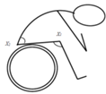
Drawing - 1. Scheme of measuring the angles of flexion in the hip and knee joint
The main difficulty in designing trousers for wheelchair users is the difficulty in measuring dynamic dimensional features, which entails large errors in the calculation of design parameters that ensure a dynamic fit for the projected posture. In the studies conducted, the problem is posed of the possibility of using known dependencies to calculate the change in dimensional features in the "sitting" position when designing clothes for people with limited motor abilities. In previous studies, mathematical models of the dependence of the change in dimensional features on the angles of the amplitude of motion in the main joints characterizing a certain posture have already been obtained. At the first stage, the relative dynamic effects of changing dimensional features corresponding to the areas of maximum change in the surface of the human body were calculated. Angle variation ranges were set between the maximum values ​​of the angular parameters of movements that were chosen taking into account the physical state and the capabilities of the subjects to fix certain positions of the lower limbsThe second stage established the correspondence of the size characteristics obtained by the regression models and the measurements taken by the person in the "sitting" position, with similar angular parameters. At the same time, the magnitude of the deviation of the calculated and experimental values ​​was calculated. Analysis of calculation and control measurements showed that the limiting error of the calculated set values ​​is very close to the limiting errors adopted in the design of clothing. A thorough study of functional, medical, aesthetic and emotional needs will eliminate many functional problems associated with clothing, reduce social self-destruction. Thus, it is possible to achieve greater social integration and development of our planet as a whole.
For the manufacture of trousers used knitwear, because it can stretch as you like thanks to the loops, which can change the size and shape[1].
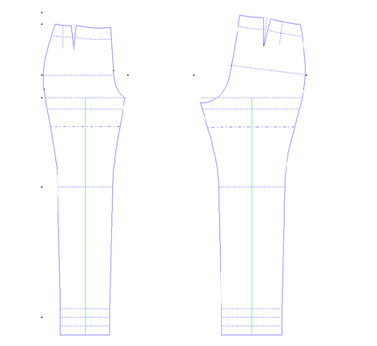
Drawing - 2. Drawing of a basis of a design of trousers from a knitted fabric (170 - 48 - 39,5)
On the basis of experimental studies, the following was revealed. Table 1 shows the calculations in accordance with the new model of trousers. The following changes were made to the design basis:
Constructive section | Note
Duck position on the front half of the trousers in the knee area | Darts solution = 4,0cm  Darts length = 9.0 cm  The distance between the darts = 2.0 cm
Elongation of the middle cut at waist level | Elongation = 10.0 cm.  From the waist line according to the elongation.
Dart position on the back half of the trousers | Darts solution = 8.0 cm  The length of the dart to the step and side cut of the rear half of the trousers.
Table - 1. Calculations of the model design of trousers
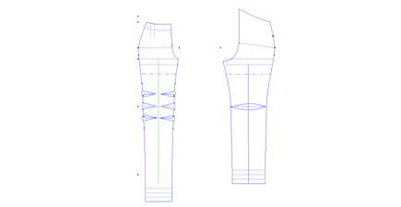
Drawing - 3. Drawing of model design of trousers from knitted fabric (170 - 48 - 39,5)
Conclusion.Based on the analysis of existing and new clothing technologies for persons with disabilities, has been developed a new model of trousers developed, which is convenient for use in wheelchairs.
List of used literature:
- Holostova V.V. On the design of clothes for women with limited motor abilities. V.V. Holostova, N.Yu. Savelyeva //Fashion and design. Modern clothes and accessories 2009: Materials between- People's Scientific and Practical Conference. –Rostov – na – Donu: Publisher - STD of the JURU, 2009. – 566p.

