УДК 004.02
APPLICATION OF MODERN IT ACHIEVEMENTS
IN FASHION BUSINESS
AbilkalamovaK. – senior teacher
Talgatbekova A. – c.t.s., head of «TCGP» department
Almaty technological university, Almaty city, RK
E-mail: kamilya.abilkalamova@mail.ru

Today, the mobile applications market is developing at a huge pace. In the West and in Asia, everyone is an active user of modern digital gadgets. In the CIS countries, the number of such users today is more than one-third part of the total.
Use of modern IT achievements in the business in the form of web applications to some niches of the market will allow you to feel real benefit in increasing sales and customer loyalty.
All mobile applications used for business can be divided into two groups:
- Programs aimed at addressing the internal needs of the company;
- Applications aimed at solving such business tasks as: increasing sales, increasing loyalty, marketing goals, branding [1].
The sphere of the fashion industry was no exception. There are some interesting modern projects in this area that use web applications to promote their business ideas.
Unsuitable size is the most important reason for the return of online shopping for clothes. The FITTERY application allows users to load examples of clothing that fit perfectly in the database. The service helps to choose options from electronic catalogs, which are the most suitable for the size of the user of the application. According to developers, the application reduces the size of the return of purchases of clothes from online stores from 40% to 6% [2].
Another application GENOSTYLE works on the basis of an algorithm that recommends buying clothes similar to the one previously purchased. Developers monitored more than 6,500 brands of clothing and developed a classification of "genomes of style", which includes the following areas: Bohemian, Classic, Edgy, Glam, Hipster, Minimalistic, Preppy, Punk / Grunge, Romantic, Sartorial, Sporty / Active, Tailored, Vintage, Western [3].
The CLOSET COLLECTIVE application is a rental and rental service for clothes presented by brands, as well as from your own wardrobe. This application is aimed at representatives of the younger generation who want to earn money and are ready to share their clothes. The application works in three stages. At the initial stage, the user from the electronic catalog chooses 3-5 pieces of clothing. At the second stage the service delivers the order and within 48 hours the user carries out the fitting and decides on the rental of products. At the last stage, unsuitable items of clothing are returned, and items that have come up can be used for a month [4].
Another application SMARTZER is an interactive digital video player that allows users to find clothes and accessories that heroes wear to the cinema and purchase them. The service also provides an analysis of information about the number of video views, the number of clicks on the panel, the top products that received the most clicks [5].
The TRENDSTOP application was created on the basis of the same-name London trend agency. The application is engaged in forecasting and high-grade coverage of the actual fashion trends.

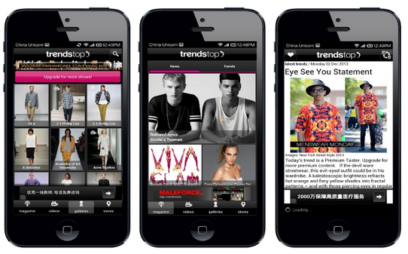

Figure 1 - The interface of the TRENDSTOP application

The CLAMOTTY application helps to choose a set of clothes from the entire range of products in the wardrobe. The user creates a virtual copy of his wardrobe (photos, barcode scanner, photos from online stores), clothing is sorted by season, and then the application creates kits. There is also the possibility of planning a wardrobe according to the calendar, the possibility of virtual combination of the liked thing with the available wardrobe for further decision making about its purchase [6].
STYLEBOP SHOPPING APP application is an analogue of an already existing site, which helps to find, select and order products from collections of designers of premium brands.
Another online store service of popular brands GILT, which specializes in constant discounts and profitable offers.
MODEST - an application that collects information about street-style images on the streets of the city.
Another application POLYVORE as well as applications of analogs as a platform for selling clothes, collects information about products of online stores. At the same time, all emerging clothing is sorted by types of products: tops, blouses, skirts, dresses, etc. The application has an interesting function of creating virtual sets from products that are in the database. Products can be sorted by price and color.

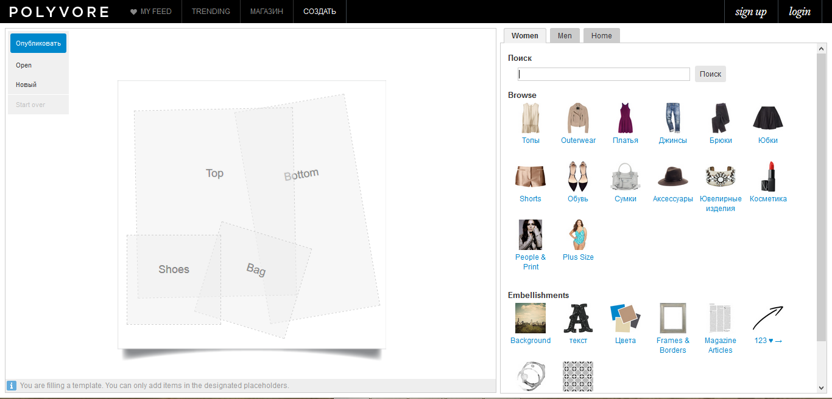

Figure 2 - The window of the module for creating virtual sets
in the application POLYVORE

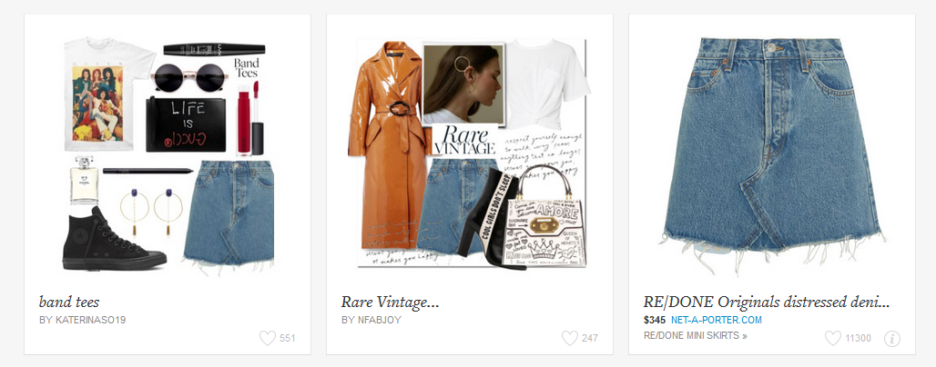

Figure 3 - Examples created in the POLYVORE
applicationvirtual kits

The web applications presented in the survey are aimed at increasing the company's sales by attracting and retaining the target audience, because an active mobile Internet user quickly gets access to the goods and interacts more intensively with the shops. Built-in features like a loyalty program or sending push notifications help in creating motivation for customers to purchase goods or services. Thus, the business is inside phones and other customer gadgets, increasing the company's contact with customers.

References
1 Development of applications for business [Electronic resource]: URL: https://www.gd.ru/articles/9560-razrabotka-prilozhenij-dlya-biznesa-komu-i-kogda-eto-nuzhno (Date of appeal: 04.04.2018)
2 Fittery [Electronic resource]: URL: http://www.fittery.com/ (Date of appeal: 12.08.2018)
3 Genostyle[Electronic resource]: URL: https://www.genostyle.com/(Date of appeal: 17.07.2018)
4 Closetcollective[Electronic resource]: URL: https://www.closetcollective.com/(Date of appeal: 25.05.2018)
5 Smartzer[Electronic resource]: URL: https://www.smartzer.com/(Date of appeal: 12.08.2018)
6 Seven trendy applications about fashion [Electronic resource]: The style// URL: http://thestyle.com.ua/fashion/2016/01/7-modnyx-prilozhenij-o-mode/(Date of appeal: 12.08.2018)
7 Polyvore[Electronic resource]: URL: https://www.polyvore.com/(Date of appeal: 04.04.2018)

