УДК 687.17
DEVELOPMENT OF A DESIGN DRAWING FOR WOMEN'S POUCH FOR WOMEN WITH LIMITED ABILITIES
Arnauyt S.A., Zhilisbayeva R.O., Doctor of Technical Sciences, Professor., Almaty Technological University, Almaty., Republic of Kazakhstan, E-mail: sandu_94love@mail.ru, Rau_45@mail.ru
Design of comfortable, aesthetically attractive, meeting the complex of specific properties and requirements of clothing for women with disabilities, allowing them to provide a high level of comfort and vitality, is a complex problem, the solution of which is at the junction of such industries as medicine, biomechanics, materials science, confection, design, anthropology, psychology, etc [1].
The urgency of the problem of disability and the organization of social protection for the disabled is due to its scale. The planet now has 1 billion 300 million people with disabilities. In the problems of people with disabilities, and another 2 billion - their relatives, medical personnel, people serving people with disabilities. Finally, another 650 million earthlings are elderly people over 65 years of age. To date, state social support for people with disabilities is one of the most vulnerable areas of social policy, given that there is an annual increase in the number of people with disabilities, including children, as well as the availability of problems in the field of accessibility of social facilities, education, employment and much other [2].
At present, there is no sewing enterprise in Kazakhstan that produces clothes for the disabled. People with disabilities have to adapt to the existing range of clothing on the market, or use custom tailoring services that are unacceptable, due to the high cost
Clothing for people with disabilities is so complex that it can be attributed to scientific development, as it uses innovative development technologies. Such clothes contribute to the country's economic growth.
To determine the characteristics of the difficulties in the operation of clothing, a survey was conducted, the results of which were entered in the tables.
Table 1 - Сharacteristics of difficulties in the use of existing clothing for wheelchair users.
Difficulty | Characteristic
When removing and putting on clothes | Cope with outside help, have difficulties in buttoning and tying the laces, not satisfied with the size of the slider, narrow armhole.
When wearing clothes | Rough seams in some areas of clothing, increased friction in the areas of the armpit.
During medical procedures | More convenient access to certain areas of medical procedures is required.
When carring for clothes | Cope with outside help, washing.
Table 2 - Requirements for clothing properties:
Denomination | Characteristic
High strength | Elbow area of sleeves, knee area
Increased softness | The back of the pants, the back of the shoulder products (spine, waist)
Increased breathability | Armpit area, back of shoulder products
Thermal protection properties | Required in the lower extremities
Moisture absorption | No requirement
Moisture repulsion | Bottom products
Antibacterial properties | The lower part of the sleeves, collars and armpit.
Elasticity | Elbow area of sleeves, knee area.
Based on the results of the survey, an improved model of the cover is proposed, the design of which is designed to meet the requirements for the properties of clothing [3].
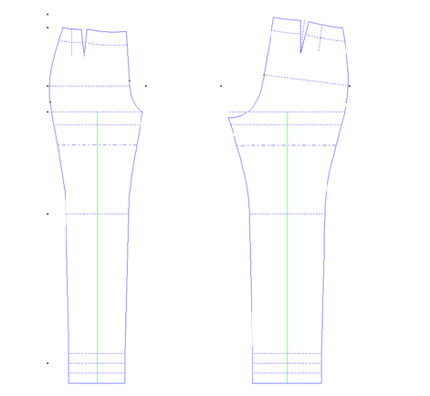
Drawing - 1. Drawing of a basis of a design of trousers (170 - 48 - 39,5)
1 Technical description
Pouch for wheelchair users, for socks in the spring summer period in rain conditions. It is made of water-repellent and dirt-repellent cloak fabric.
The front part of the bag is completely unfastened, fastened with a zip along the entire length of the part. Lightning can withstand multiple loads. Lightning engines can have special rings that provide ease of use for people with traffic restrictions and are experiencing difficulty in using small parts. The length of the front part allows you to cover a seated person to a level of 15-20 cm above the waist line. The back of the bag is high, completely covers the back, fixed with a Velcro tape on the stroller handles or other metal fasteners. The design of the bag repeats the bends of the human body in the region of the knee and buttocks.
The bottom of the bag is made from artificial leather.
The size range is graded depending on the growth: 164 – 48 – 52
164 – 50 – 54
164 – 52 – 56
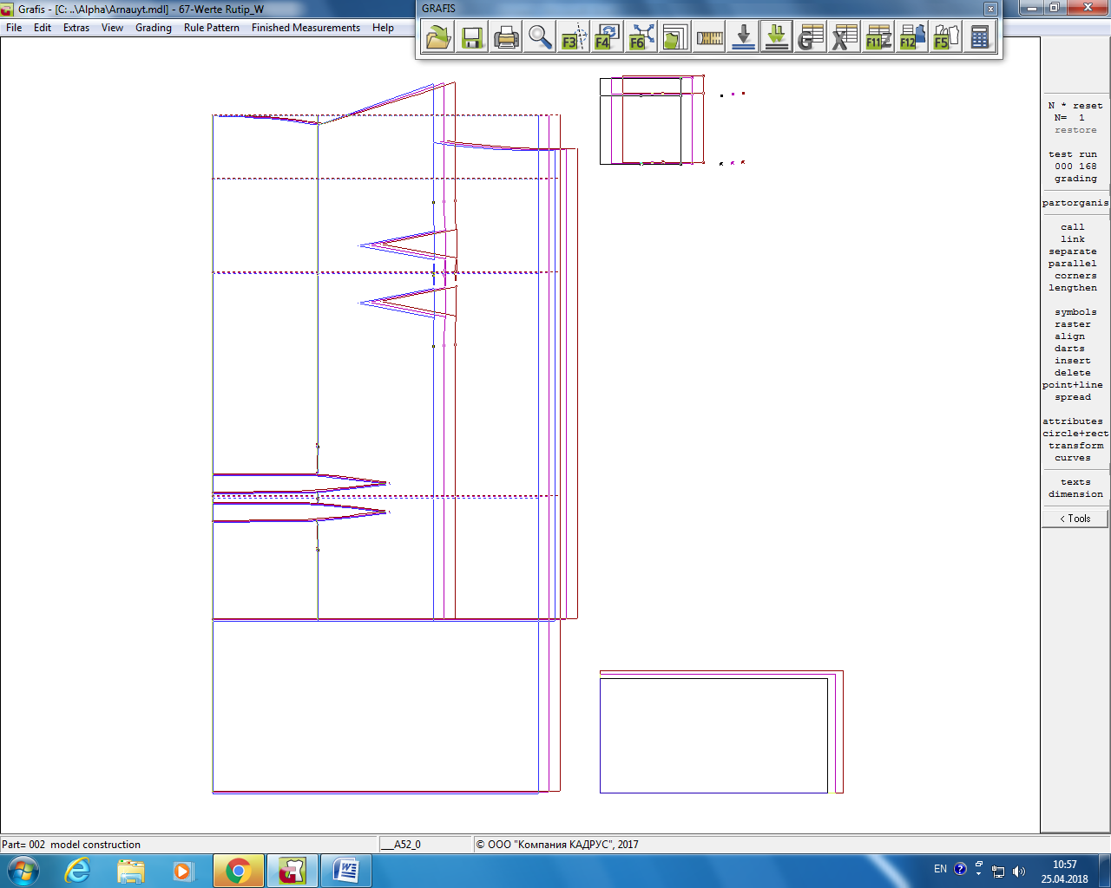
Drawing - 2. Drawing of model design of pouch for wheelchair users (170 - 48 - 39,5)
2 Specification of part
Table 3 - Specification of part from of pouch for wheelchair users
Patterns from the main tissue
1 | Back part | 1*1
2 | Front part | 1*2
3 | Strap | 1*2
4 | Pocket | 1*2
Artificial Leather Patterns
5 | The bottom of the bag | 1*1
6 | Bottom of bag | 1*1
Patterns from lining fabric
7 | Back part | 1*1
8 | Front part | 1*2
9 | The bottom of the bag | 1*1
10 | Bottom of bag | 1*1
Figure 3 suggests the layout of the cover from the lining fabric.
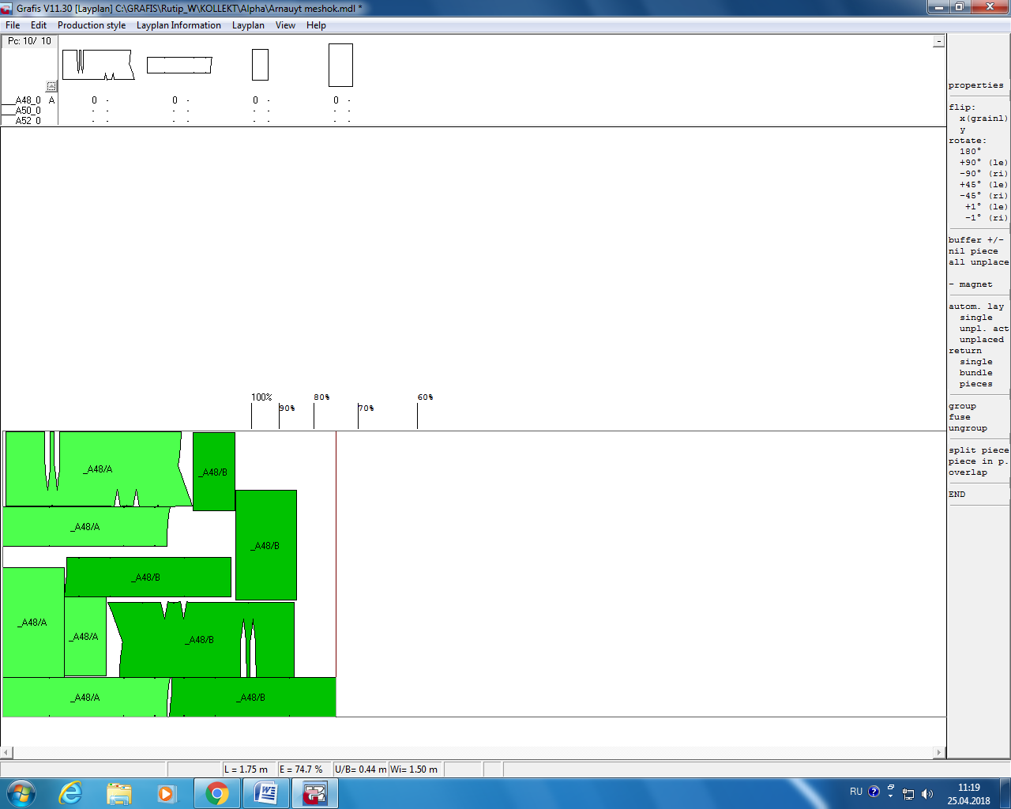
Drawing - 3. Layout of parts from lining fabric
Conclusion.
As a result of the work, was developed a new design of pouch for women with a limited capacity, in which was used the Grafis program. The specification of details and a lining on a lining fabric is offered.
List of used literature:
- //https://www.istok-audio.com/info/articles/bezbarernaya_sreda/Specialnaja_odezhda_dlja_invalidov-koljasochnikov/
- http://www.kriptomed.com/news/spetsialnaya_odezhda_dlya_lyudey_v_kreslakh_kolyaskakh/
- Holostova V.V. On the design of clothes for women with limited motor abilities. V.V. Holostova, N.Yu. Savelyeva //Fashion and design. Modern clothes and accessories 2009: Materials between- People's Scientific and Practical Conference. –Rostov – na – Donu: Publisher - STD of the JURU, 2009. – 566p.

